## GUJARAT TECHNOLOGICAL UNIVERSITY

Chandkheda, Ahmedabad

Affiliated

 

L.J. Institute of Engineering Technology

**A Report On:**

**SMART HOME WEBSITE**

Under subject of

DESIGN ENGINEERING – 1A

B. E. Semester – III

Information Technology/ Information & Communication Technology

Submitted by

|  |  |  |
| --- | --- | --- |
| Sr. | Name of student | Enrollment No. |
| 1 | Patel Rahul Manojbhai | 190320116046 |
| 2 | Sathe Sanket Manojbhai | 190320116062 |

Mr. Zishan Shaikh Mr. Saurin Dave

Faculty Guide Head Of Department

Academic year (2020-21)

**Acknowledgement**

I would like to express my special thanks of gratitude to my faculty (**Name of the Faculty**) as well as our principal **Mr. Mitesh Thakker** who gave me the golden opportunity to do this wonderful project on the topic **(Smart Home Website)**, which also helped me in doing a lot of Research and i came to know about so many new things I am really thankful to them.  
Secondly i would also like to thank my parents and friends who helped me a lot in finalizing this project within the limited time frame.

- Patel Rahul M.

-Sathe Sanket M.

**Smart Home**

**INDEX**

|  |  |  |
| --- | --- | --- |
| No. | TITLE | PAGE NO. |
| 1. | **Introduction** | **3** |
| 2. | **Canvas**  2.1.AEIOU CANVAS  2.2.IDEATION CANVAS  2.3.EMPATHY CANVAS  2.4.PRODUCT DEVELOPING CANVAS | **4**  **4**  **10**  **15**  **19** |
| 3. | **USER FEADBACK & ROUGH PROTOTYPE**  3.1 Version 1.0 Prototype | **26** |
| 4. | **Prior Art Search**  4.1Research Paper Summary | **27**  **27** |
| 5. | **CONCLUSION** | **31** |
| 6. | **REFERENCES** | **32** |

1. **INTRODUCTION**

**Subject :- Information about How to make your home Smart ?**

This Project is regarding to how to make your own home smart by Some kind of censors and devices. In this project our website is easily available All the Devices and censors which can make your home smart and we are putting all the information about all kind of devices and their Uses , and How to operate all kind of devices and censors.

**2.CANVAS**

**2.1. AEIOU Canvas :-**

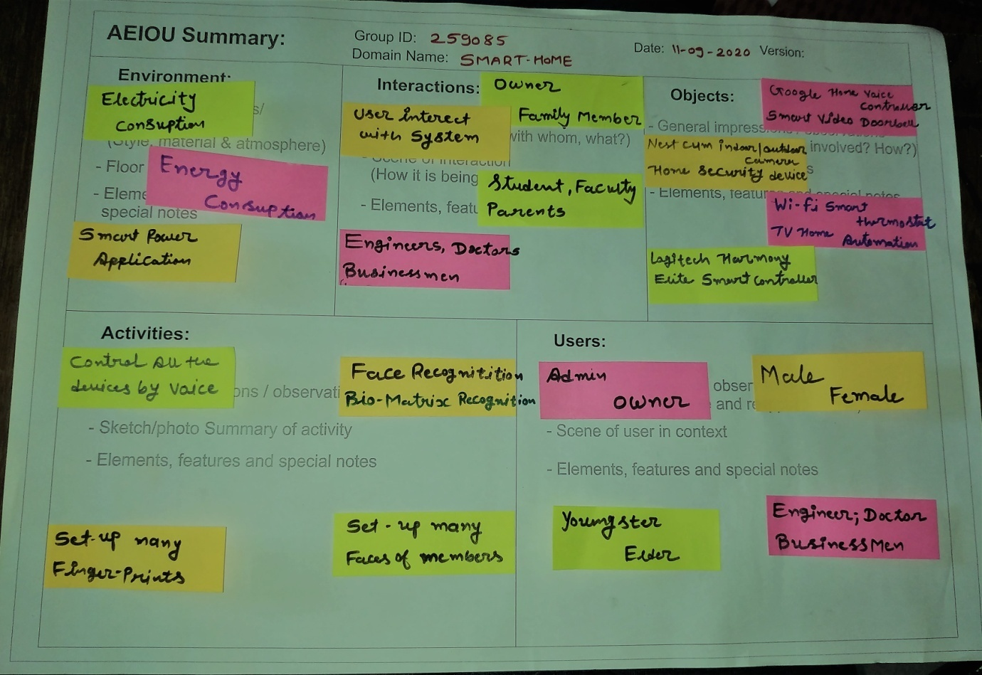

**Activities:-**

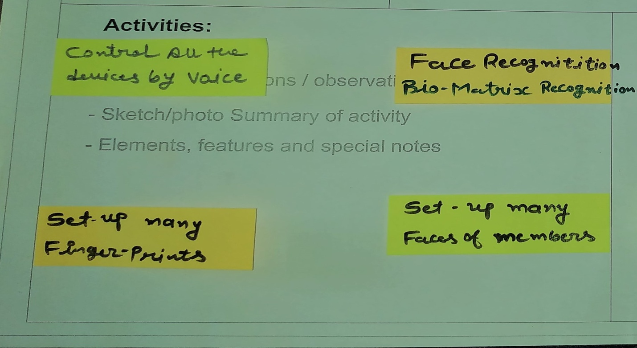

* Our website is showing the things which can control all the devices by their voice of the owner.
* Our website is exhibit the many devices , which can recognize the owners face and bio-matrix prints.
* It has devices which help to watch all the activities at your children at the home.

**Interactions:-**

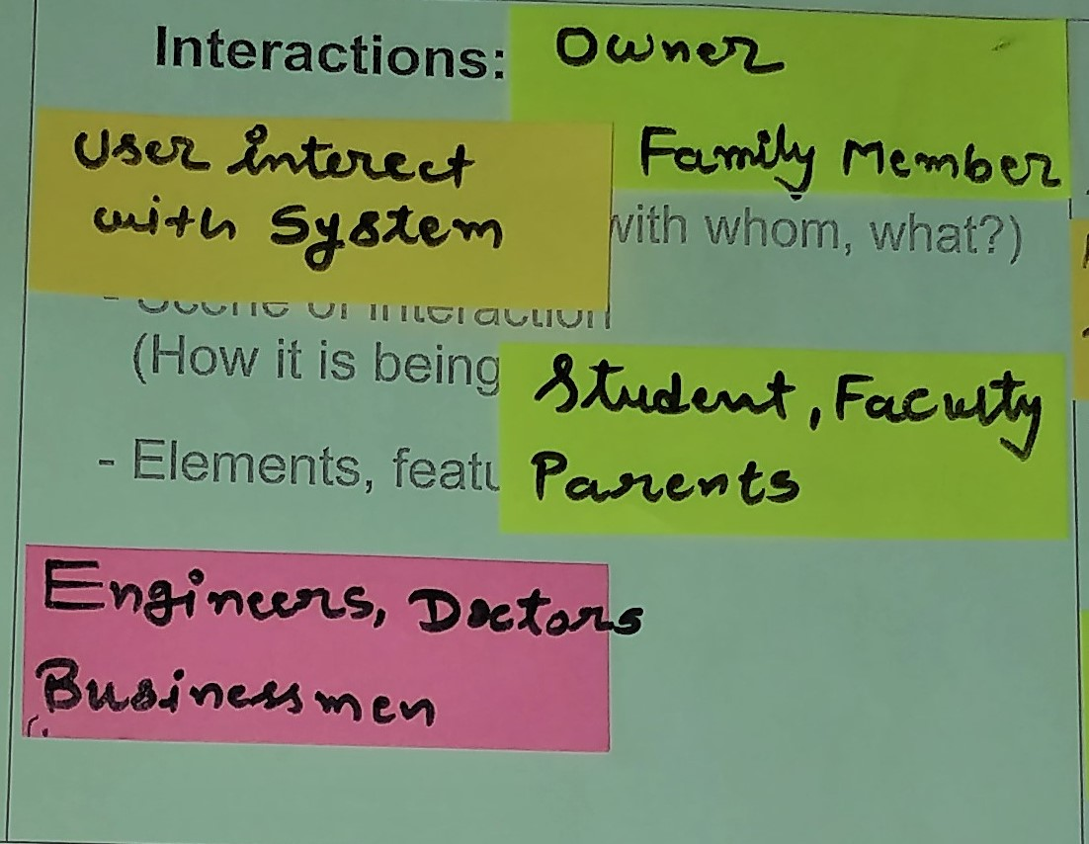

* + User interact with the system.
  + Our website is helpful for the owner and their family member.
  + The website use by all the students, faculties, Engineers, Doctors, Businessman.

Users :-

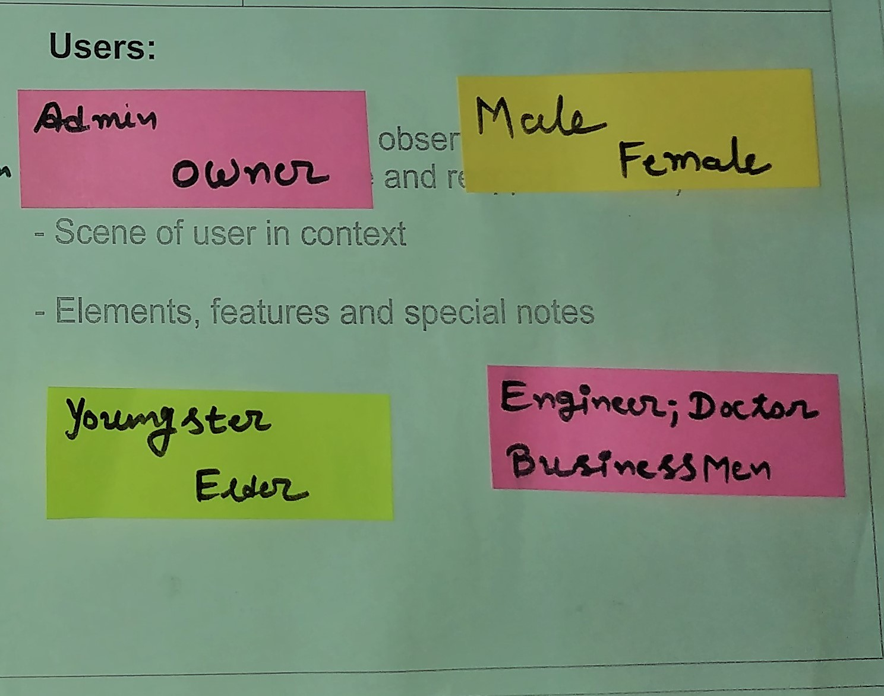

* The users are Admin, The user of the website owner,

Youngsters

Elders

Engineers

Doctors

Businessmen

**Object :-**

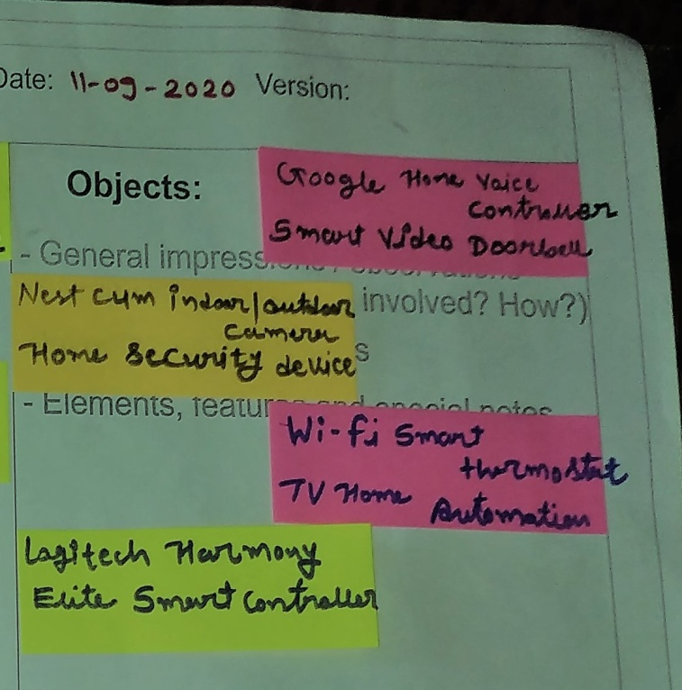

* Google Smart Home Voice Controller
* Smart Video Doorbell
* Nest Cam Indoor/ Outdoor Camera
* Home Security Devices
* Wi-Fi Smart Thermostat
* Logitech Harmony
* Navdy – Smart Navigation System

**Environment:-**

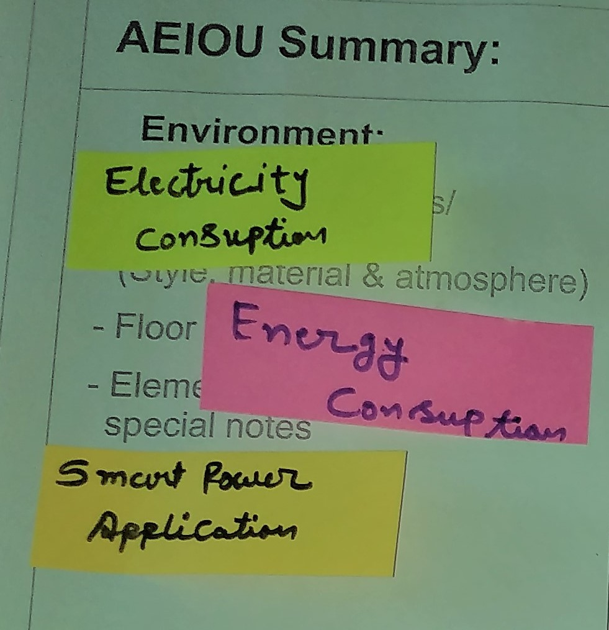

* Our Website is not harm Environment at any cost.
* It is use to Power Consumption, Enery consumption.
* It is all the devices only operate by the smart Home Application.

2.2 Ideation Canvas:-

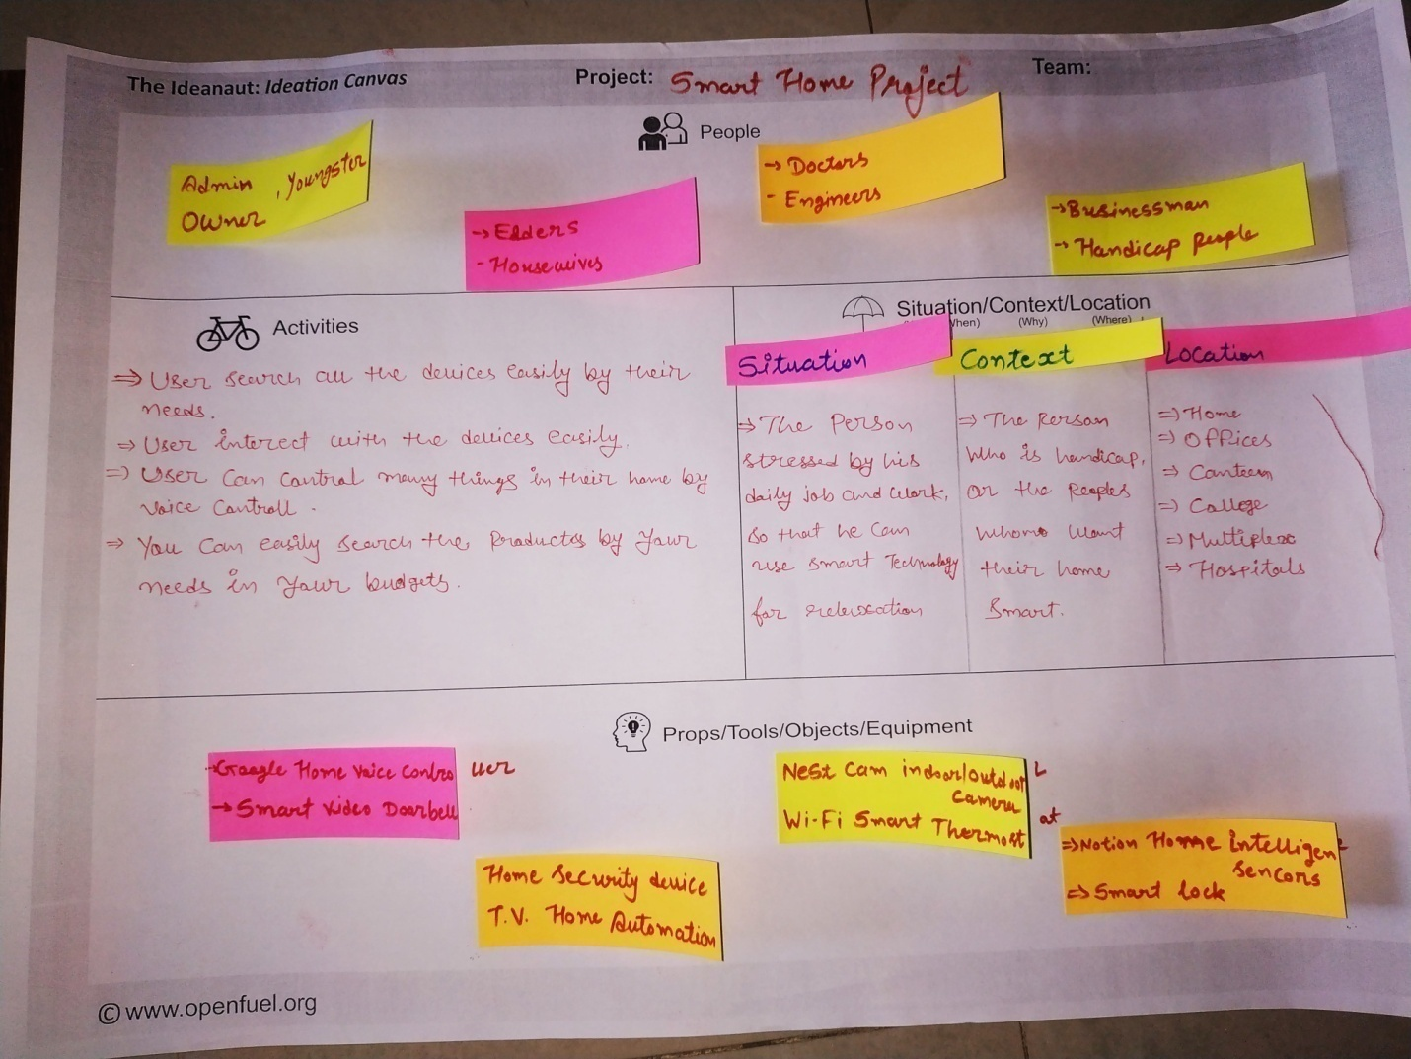

**➢ SITUATION/CONTEXT/LOCATION:-**

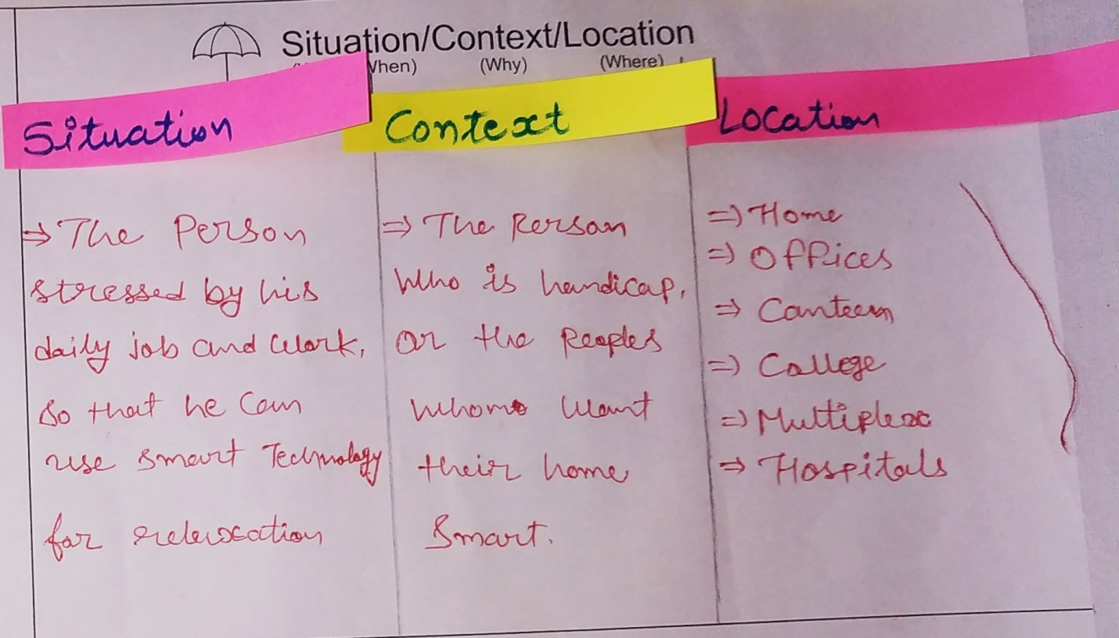

* **Situation :-**

**:-**The Person stressed by his daily job and work so that he can use smart technology for relaxation.

* **Context :-**

**:-**The person who is handicap, or the peoples whom want their home smart.

* + **Location :-** we are using the devices at the home , Offices , colleges, at multiplex, which can help us easily to use and our daily life.

## 

**➢ PROPS/TOOLS/OBJECTS/EQUIPMENTS:-**

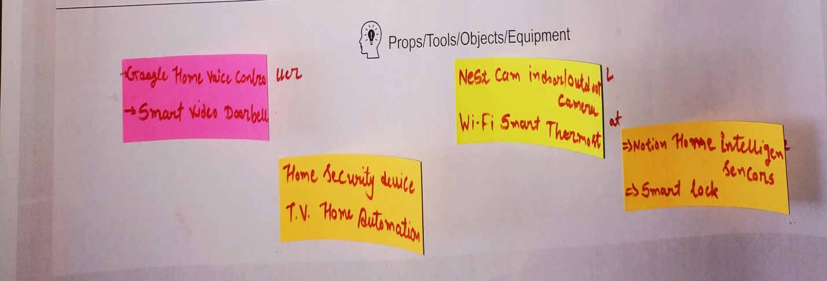

* Google Smart Home Voice Controller
* Smart Video Doorbell
* Nest Cam Indoor/ Outdoor Camera
* Home Security Devices
* Wi-Fi Smart Thermostat
* Logitech Harmony
  + - Navdy – Smart Navigation System

**➢ ACTIVITIES:-**

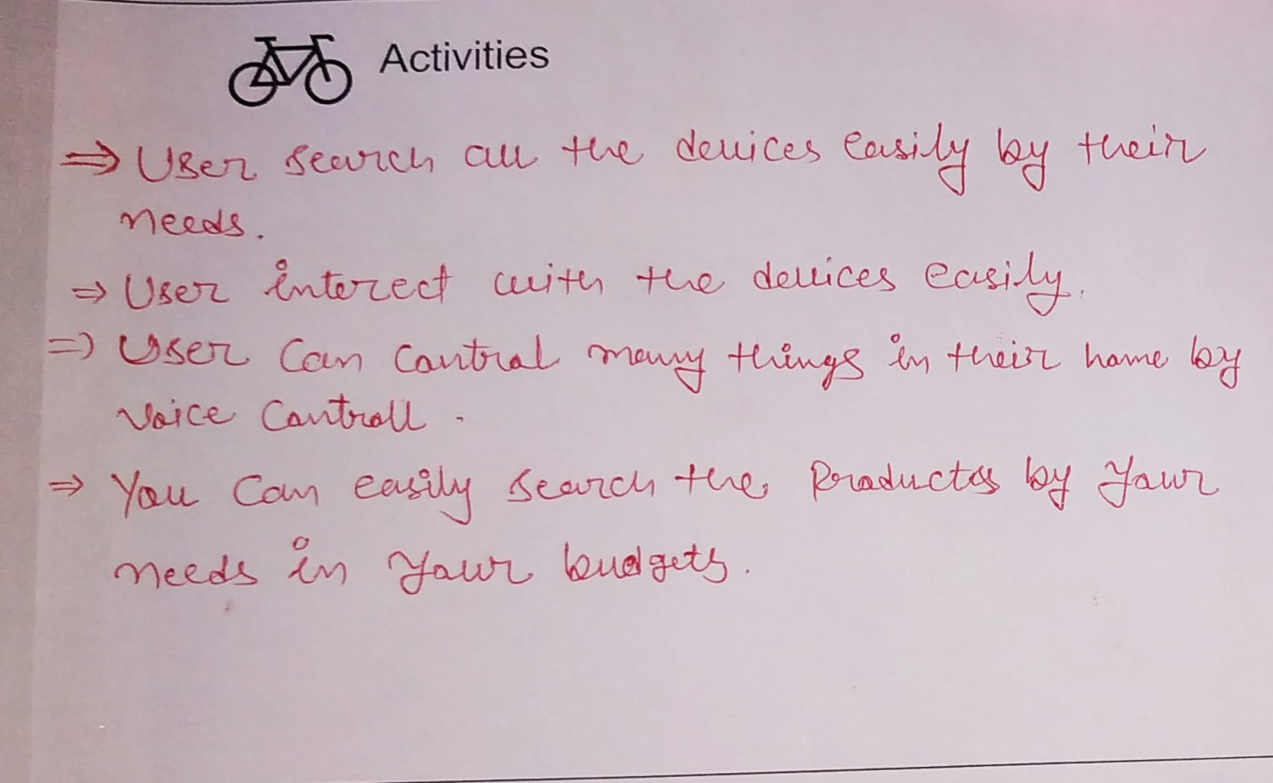

* + User search all the devices easily by their needs .
  + User interact with the devices easily.
  + User can Control many things in their home by voice Controller.
* Our website is showing the things which can control all the devices by their voice of the owner.
* Our website is exhibit the many devices , which can recognize the owners face and bio-matrix prints.
* It has devices which help to watch all the activities at your children at the home.

**➢ PEOPLE:-**

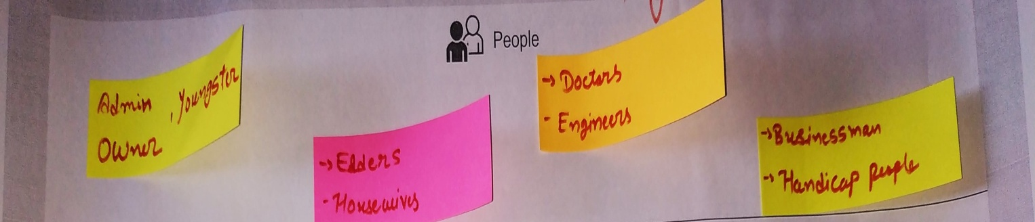

* The users are Admin, The user of the website owner ,Youngsters ,Elders ,Engineers, Doctors

Businessmen.

**2.3 Empathy Mapping Canvas:-**

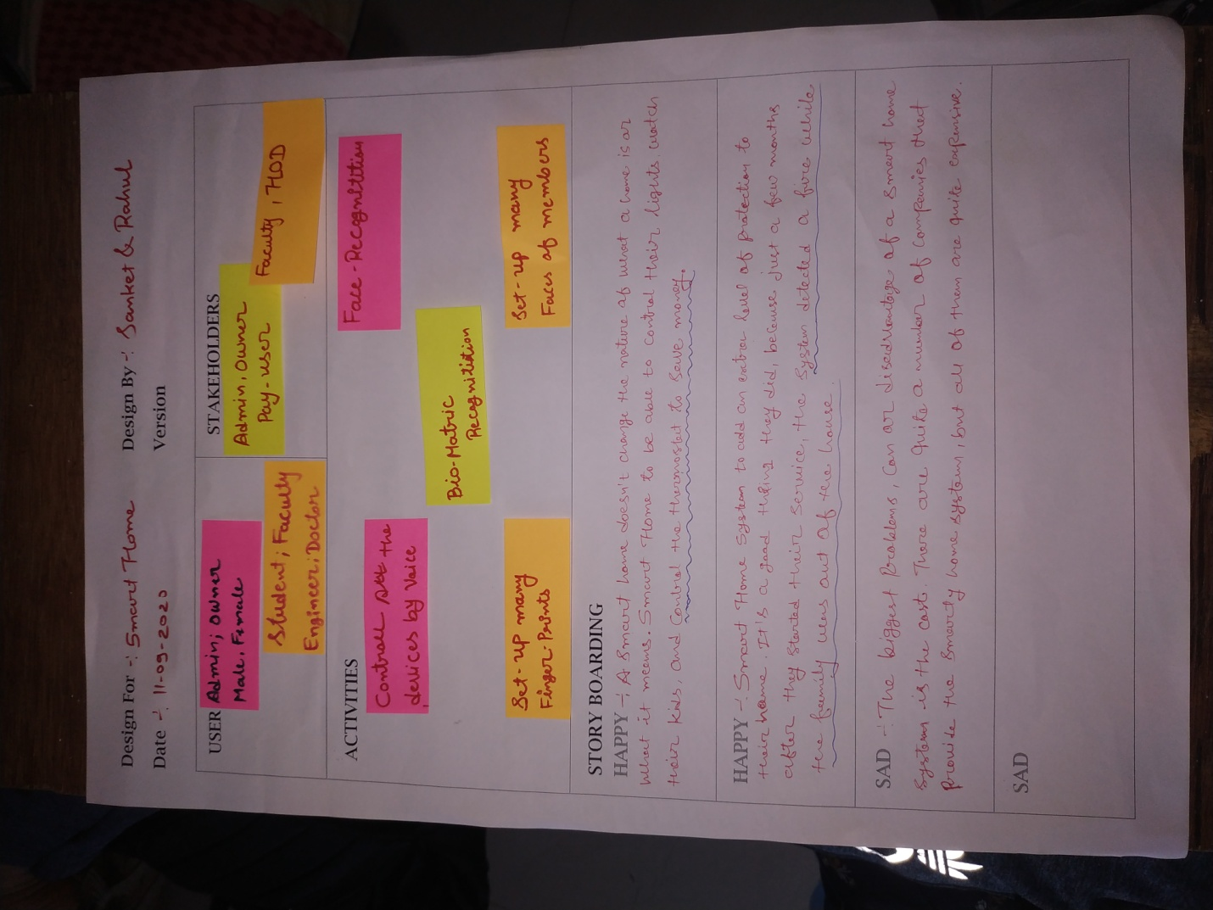

**➢ USER:-**

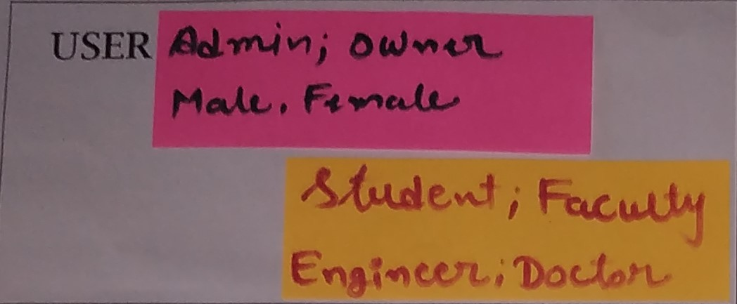

* The users are Admin, The user of the website owner,

Youngsters

Elders

Engineers

Doctors

Businessmen

**➢ Stakeholders :-**

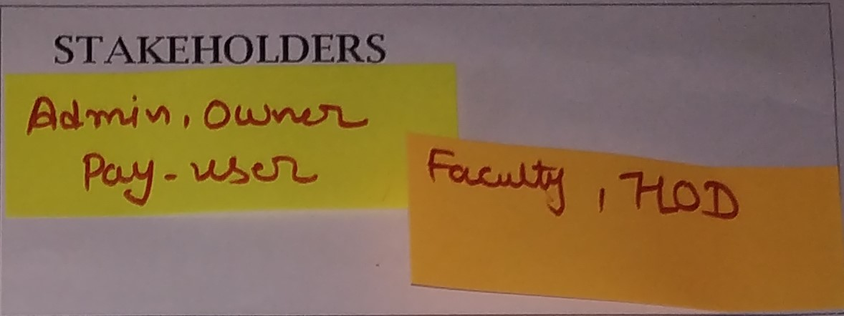

* Admin
* Owner
* Pay-Users
* Faculty
* HOD

**Activities**

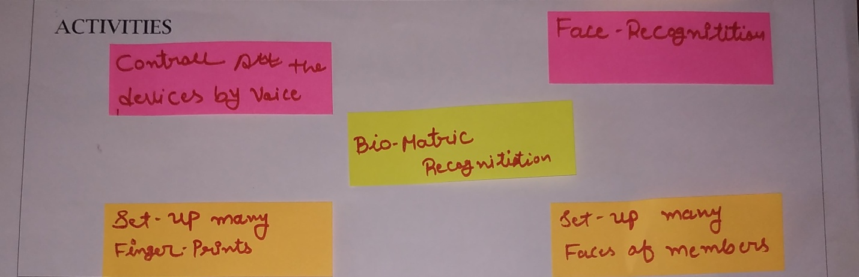

* + User search all the devices easily by their needs .
  + User interact with the devices easily.
  + User can Control many things in their home by voice Controller.
* Our website is showing the things which can control all the devices by their voice of the owner.
* Our website is exhibit the many devices , which can recognize the owners face and bio-matrix prints.
* It has devices which help to watch all the activities at your children at the home.

**2.4.Product Development Canvas:-**

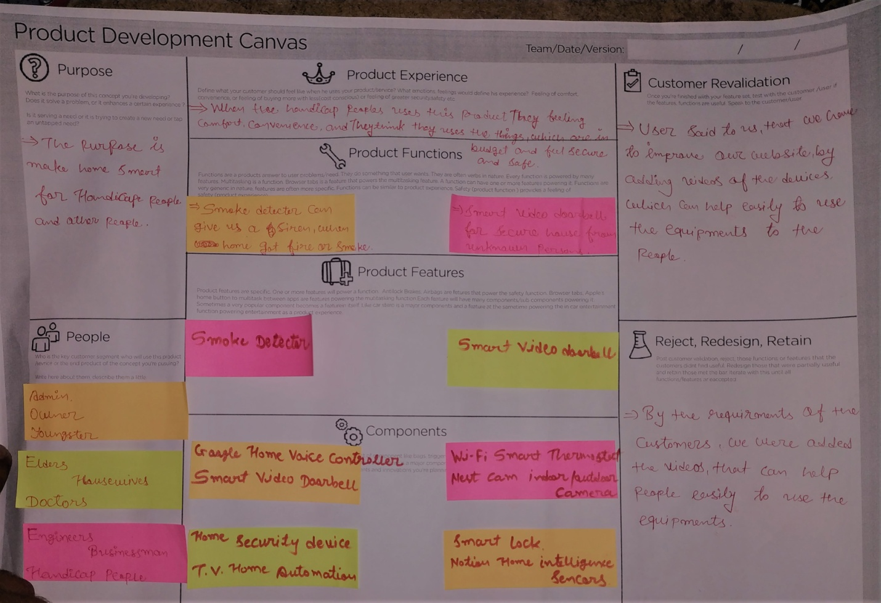

**➢ Purpose:-**

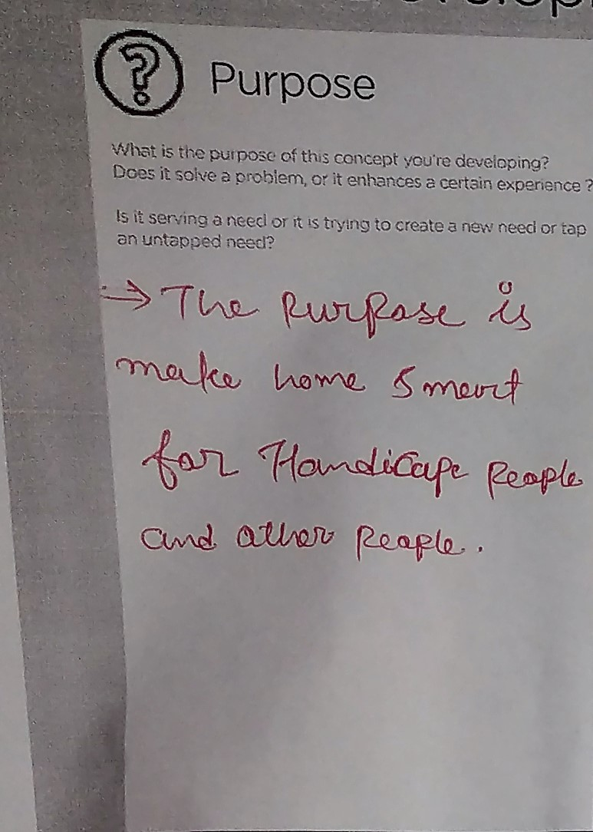

* The purpose is make home smart for Handicap people and other people.

**➢ People:-**

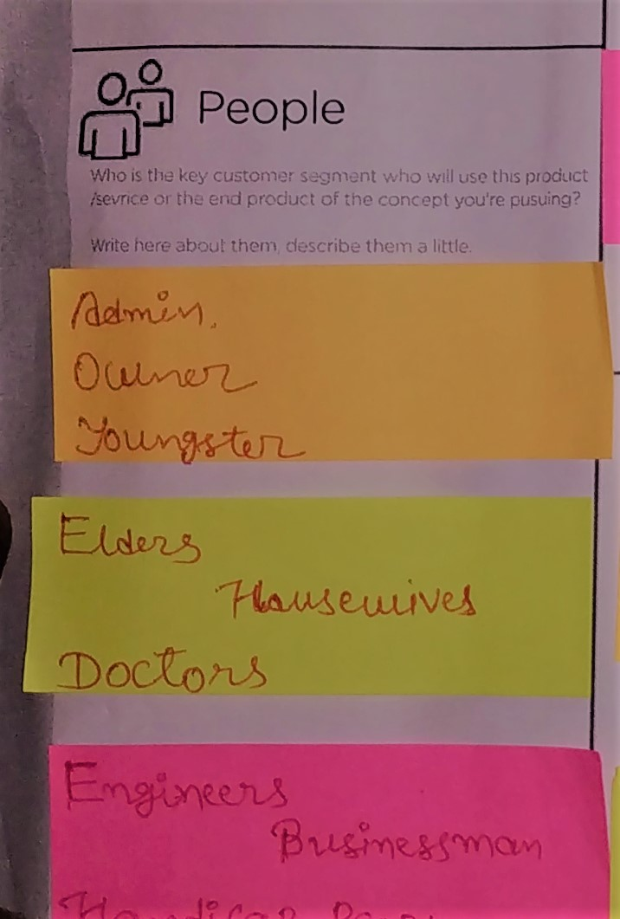

* The users are Admin, The user of the website owner ,Youngsters .Elders, Engineers ,Doctors

Businessmen

**➢ Product Experience:-**

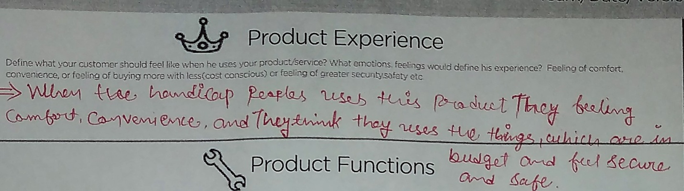

* When the handicap peoples uses this products , they felling comfort , convenience, and they think they uses the things , where they can feel secure And safe.

**➢ Components:-** 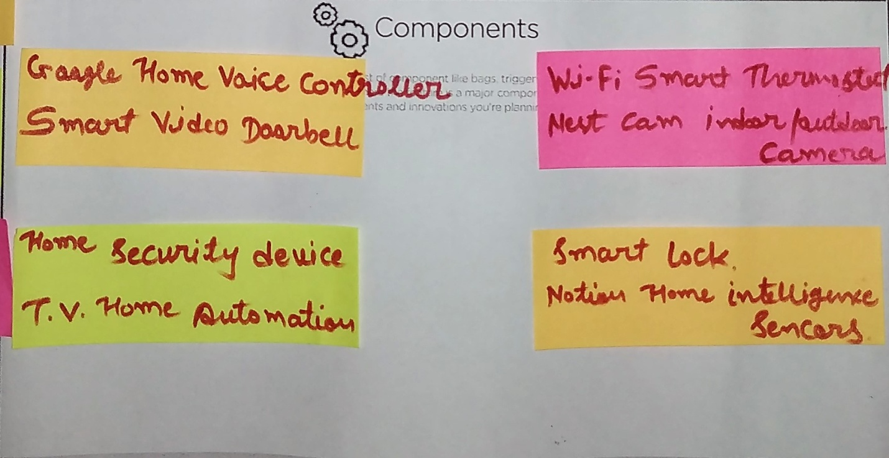

* Google Smart Home Voice Controller
* Smart Video Doorbell
* Nest Cam Indoor/ Outdoor Camera
* Home Security Devices
* Wi-Fi Smart Thermostat
* Logitech Harmony
  + - Navdy – Smart Navigation System

**➢ Customer Revalidation:-**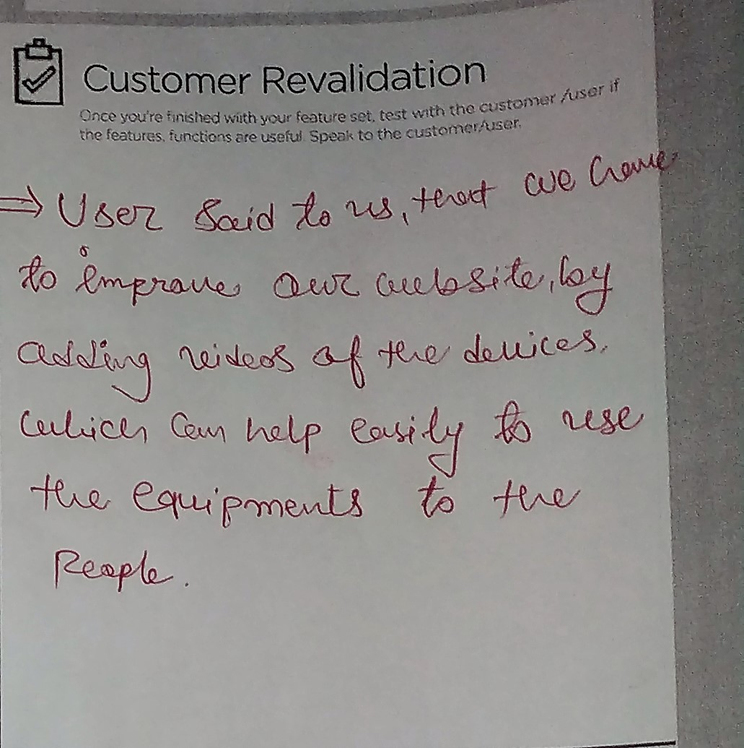

* User said to us, that we have to improve our website, by adding videos of the devices, which can help easily to use the equipments to the people.

➢ **Reject, Redesign, Retain:-**

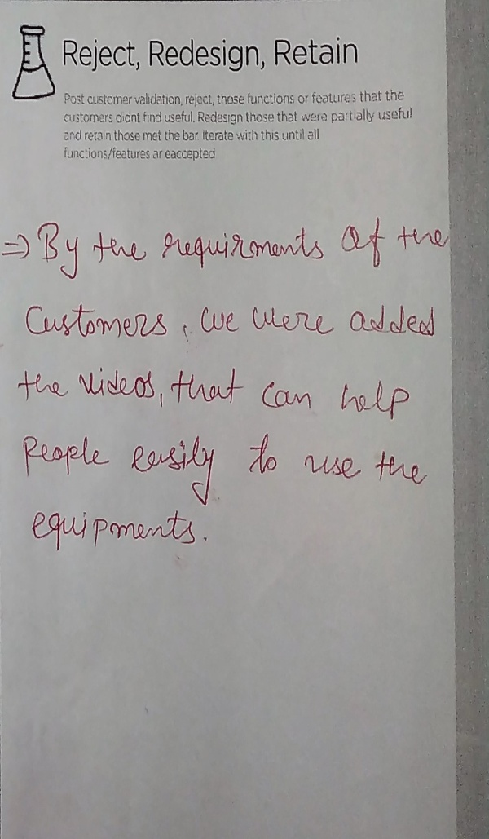

* By the requirements of the customers, we were added the videos, that can help people easily to use the equipment.

**3. USER FEEDBACK AND PROTOTYPE**

Many smart house systems have been presented, but there are still some limitations in terms of the high cost, less functionality, difficulty of use that are not satisfactorily reliable and cannot be developed. Therefore, the aim of this research project was to design and develop a prototype for a smart house system that is low cost, has a user-friendly interface, and is scalable and reliable by using an integrated system of hardware and software. The hardware, such as Arduino Uno, servo motors, a temperature sensor, a motion sensor and a battery, was utilized to develop the prototype of a smart house system. The software included Arduino integrated development environment (IDE) to compile the code in hardware and using MIT App Inventor for Android mobile phones to interfacing a mobile handset with hardware. Moreover, In order to make the design of prototype more professional, Sweet Home 3D software was used. The system has been evaluated with the previous works and it was demonstrated to six experts to obtain some feedback on the prototype. The testing of the prototype demonstrated that the system was an integrated, practical and easy to use, and any new device could easily be installed into the system. The aim of this research project has been achieved successfully. However, the prototype requires further developments, which include the power supply reliability, use other wireless technologies such as Wi-Fi and ZigBee, and cross-platform apps to work with differently operated systems such as iOS for people use Apple devices by using MIT App Inventor.

**3. PRIOR ART SEARCH**

* 1. **Research Paper Summary**

**1.** The Energy Aware Smart Home

**Published in:**[2010 5th International Conference on Future Information Technology](https://ieeexplore.ieee.org/xpl/conhome/5482537/proceeding)

In this paper, we present a novel smart home system integrating energy efficiency features. The smart home application is built on top of Hydra, a middleware framework that facilitates the intelligent communication of heterogeneous embedded devices through an overlay P2P network. We interconnect common devices available in private households and integrate wireless power metering plugs to gain access to energy consumption data. These data are used for monitoring and analyzing consumed energy on device level in near real-time. Further, transparent information about the energy usage can be used to efficiently program and control home appliances depending on various factors, e.g. the electricity price. Making more and more data available to end-users, brings with it further challenges in the area of user interfaces. Hence, we complete the smart home system by intuitive user interfaces presenting energy consumption data in meaningful contexts and allowing end users to interact with their environment. We argue, that the combination of both, a technically sophisticated smart home application and at the same time transparent, intuitive user interfaces showing information regarding the energy usage, e.g. energy price, energy source, standby consumption etc., has the potential to bring the vision of the energy efficient smart home within reach.

2**. Middleware for Wireless Devices and Sensors - Energy Efficiency at Device Level**

**Published in:**[2010 7th Annual IEEE Communications Society Conference on Sensor, Mesh and Ad Hoc Communications and Networks (SECON)](https://ieeexplore.ieee.org/xpl/conhome/5508188/proceeding)

## The HYDRA project develops middleware for networked embedded systems that allows developers to create ambient intelligence applications based on wireless devices and sensors. Through its unique combination of Service-oriented Architecture (SoA) and a semantic-based Model Driven Architecture, HYDRA will enable the development of generic services based on open standards. A smart home application is built that facilitates intelligent communication of heterogeneous embedded devices through an overlay P2P network. We interconnect common devices available in private households and integrate wireless power metering plugs to gain access to energy consumption data. These data are used for monitoring and analyzing consumed energy on device level in near real-time.

# 3. A review of smart home applications based on Internet of Things

**Publish in:-** Received 19 February 2017

## The new and disruptive technology of [smart home applications](https://www.sciencedirect.com/topics/engineering/smart-home-application) (hereafter referred to as apps) based on [Internet of Things](https://www.sciencedirect.com/topics/engineering/internet-of-things) (IoT) is largely limited and scattered. To provide valuable insights into technological environments and support researchers, we must understand the available options and gaps in this line of research. Thus, in this study, a review is conducted to map the research landscape into a coherent taxonomy. We conduct a focused search for every article related to (1) smart homes, (2) apps, and (3) [IoT](https://www.sciencedirect.com/topics/engineering/iot) in three major databases, namely, Web of Science, Science Direct, and IEEE Explore. These databases contain literature focusing on smart home apps using IoT. The final dataset resulting from the [classification scheme](https://www.sciencedirect.com/topics/engineering/classification-scheme) includes 229 articles divided into four classes. The first class comprises review and survey articles related to smart home IoT applications. The second class includes papers on IoT applications and their use in smart home technology. The third class contains proposals of frameworks to develop and operate applications. The final class includes studies with actual attempts to develop smart home IoT applications. We then identify the basic characteristics of this emerging field in the following aspects: motivation of using IoT in smart home applications, open challenges hindering utilization, and recommendations to improve the acceptance and use of smart home applications in literature.

# 4. Benefits and risks of smart home technologies

**Published in :-** Received 8 September 2016.

## Smart homes are a priority area of strategic energy planning and national policy. The market adoption of smart home technologies (SHTs) relies on prospective users perceiving clear benefits with acceptable levels of risk. This paper character the perceived benefits and risks of SHTs from multiple perspectives. A representative national survey of UK homeowners (n=1025) finds prospective users have positive perceptions of the multiple functionality of SHTs including energy management. Ceding autonomy and independence in the home for increased technological control are the main perceived risks. An additional survey of actual SHT users (n=42) participating in a smart home field trial identifies the key role of early adopters in lowering perceived SHT risks for the mass market. Content analysis of SHT marketing material (n=62) finds the SHT industry are insufficiently emphasising measures to build consumer confidence on data security and privacy. Policymakers can play an important role in mitigating perceived risks, and supporting the energy-management potential of a smart-home future. Policy measures to support SHT market development include design and operating standards, guidelines on data and privacy, quality control, and in situ research programs. Policy experiences with domestic energy efficiency technologies and with national smart meter roll-outs offer useful precedents.

# 4.CONCLUSION

In conclusion, the main goal of this project was to design and implement a smart house system by controlling the doors, windows, lights, electricity and temperature by using an Arduino Uno and a mobile phone, and it has been achieved. This research project also represented a good beginning point to develop a smart house system that could be someday met at low cost that is easy to use and reliable. It strengthens the argument made in this research that, due to the advancement of technology, it is possible to improve systems at low cost and in a multi-functional way, which required a relatively low level of maintenance. The testing of the prototype demonstrated that the system was easily used and any new devices that are reliable, scalable for development and of the very low cost compared to the current products available in the market can be installed on it. The overall cost of the system was approximately £100, which was determined as the price of each component that has been utilized in this project. Nevertheless, the price of the prototype will be reduced when it is presented in the market so all individuals, especially in developing countries, can take advantage. System testing of software and hardware has been applied to conduct on a complete, integrated system also to evaluate the system's compliance with its specific requirements. And the result was all stages work fine. Finally, this research provides useful lessons and information that could be utilized to support future research.

**5. REFERENCE**

<http://mysmarthome6com.wordpress.com/>